

**Date: 27-04-2022**

This is to certify that Ms. **Shaik.Vasimunnisa.Begum** has successfully completed her internship in our organization during the period of

**21-04-2022** to **27-04-2022**

During the internship period, she handled operations of storage materials.

During the course of internship, she shown great amount of responsibility sincerity and a genuine willingness to learn and zeal to take on new assignments & challenges. In particular, her coordination skills and communication skills are excellent and attention to details is impressive

We wish her all the very best for her future.

With regards

S. Chaitanya Bhuvan Kumar

Store Manager



**INSTITUTE OF AERONAUTICAL ENGINEERING**

**(Autonomous)**

Dundigal-Hyderabad - 500 043

**Field Project (FP) Report**

# 1. Student Details:

|  |  |
| --- | --- |
| Name of the Student | Shaik.Vasimunnisa.Begum |
| Roll Number | 20951A05G9 |
| Department | Computer Science and Engineering. |
| Year / Semester | II Year / IV Semester. |
| Mobile Number | 8074132138 |
| Email ID | 20951a05g9@iare.ac.in |

# 2. Mentor Details :

|  |  |
| --- | --- |
| Name of the Mentor | S. Chaitanya Bhuvan Kumar. |
| Organization | Nagarjuna Construction Company Limited (NCC). |
| Designation | Store Manager. |
| Email ID | NA |
| Mobile Number | 4023268888 |

**3.Title of the field project:**

***Challenges Of Construction Company.***

**4. Purpose:**

The objective of this field project was to be a world-class construction and infrastructure enterprise committed to quality, timely completion, customer satisfaction, continuous learning and enhancement of stakeholders' value. To be a responsible corporate citizen committed to the social cause.

# 5.Description of the project:

* **Introduction:**

This report is a 1 week AICTE Field Project on construction site with the name Nagarjuna Construction Company Limited. NCC Ltd is an India-based company that is engaged in the construction sector primarily through its two major subsidiaries, NCC Urban and NCC Infra. NCC Urban focuses on the development of residential and commercial complexes, serviced apartments, an integrated township, and so on. NCC Infra undertakes the development of infrastructure projects through government concessions. Infrastructure projects developed by the company include roads, bridges, flyovers, water supply and environment projects, power transmission lines, irrigation, and hydrothermal power projects. NCC generates substantially all its sales from the Indian domestic market.

The company that I have worked with for the AICTE Field Project is Nagarjuna Construction Company Limited (NCC) located in Khanapur, Gandipet -Hyderabad. A company that contributes to India’s progress through landmark infrastructure projects which demonstrate far-reaching impact - beyond the realm of construction. They have evolved as a leading mother brand with BOT, Realty and International businesses. The need to change their name was therefore, compelling, to build a better link between the parent company and the group companies. NCC Limited is their chosen new identity, which encompasses all that they do today and aspire to do in the future.

* **Nature of Work:**

The nature of work in this Field Project is to creating world-class infrastructure is the key to building a resurgent India. The high level of economic growth that India has witnessed in recent years has resulted in industry expansion, increased commerce and per capita income - all of which have fuelled the demand for infrastructure services. The Governments, both Central and State, are doing all that it takes to foster rapid infrastructure development via Public Private Partnerships (PPPs).

NCC Infra is an infrastructure development company and a wholly-owned subsidiary of NCC. Undertaking the development of infrastructure projects through Government concessions, NCC Infra primarily focuses on long-term infrastructure projects that offer stable revenue streams.

The main problem identified in this company was about that they have to complete their construction work that may be anything regarding buildings, dams, roadways, flyovers or anything within the given period of time for them as a target date to finish the work. Due to many reasons like insufficient stock of material required, weather conditions, labourers in less count for the work or by the work load the production of the work gets delayed and finishing of the project will be postponed or stopped.

Another of the reason is that of pollution. As the company located at the outskirts of the city and areas surrounding the company is totally urban the rate of pollution comes from that place is high and due to pollution workers working out there get affected by it.

Also one of the problem is the data entry of all materials, goods, equipments required in the construction site are not properly settled and managed they are just entering into the book as a record and maintaing a general record of it, A proper structured record is not available .

**6. Observations:**

The solution of the problem was discussed and suggested that to maintain a source control between the vehicles and engines which release large amount of smoke while working also to maintain a clean environment for the workers working there for their better health .The industry site selection for the construction purpose should be selected as far from the city which would be better for areas surrounding by them. And also to maintain proper treatment of industrial waste by not polluting the land .

For the records a proper data entry in the system was established in a Microsoft excel, All the entries of goods, materials, equipments, the entry of new construction project, the total entry of Inputs and outputs all were settled and maintained in order by the use of Excel and also Database management system by creating separate tables for every possible inputs and outputs.

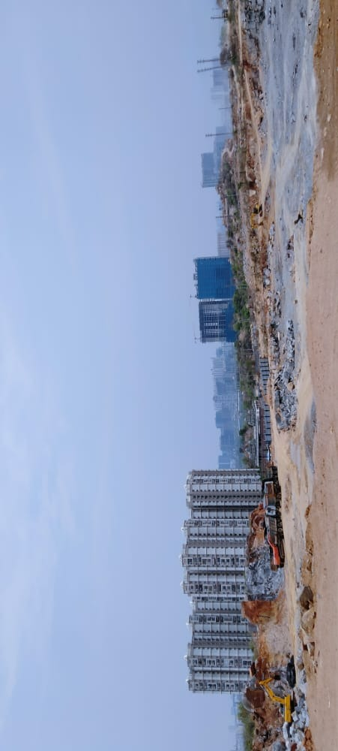As for the workers and people working there to find a peaceful and beneficial solutions for the problems, also suggested to maintain an ambulance for people who get injured while working. I came several hurdles during the development of the solution to interact with the people ,but was able to overcome them in the due course of time .

**7. Photos of field project with description:**



IMG1: The Construction site of NCC

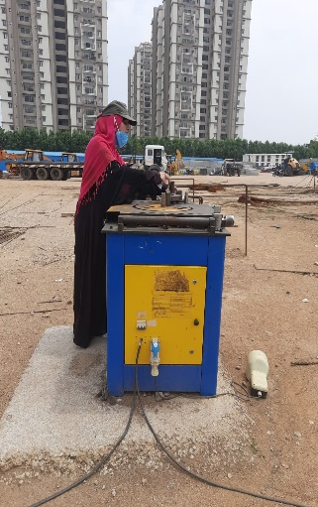 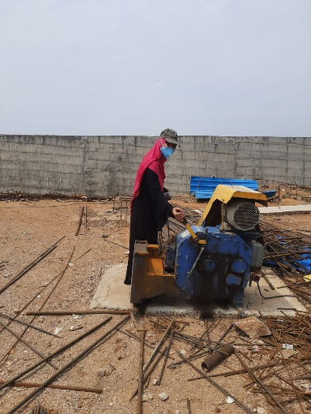 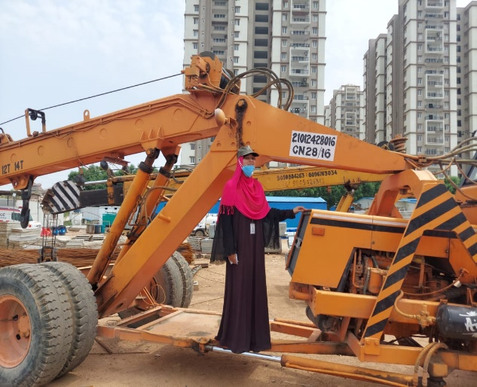

IMG2: Checking the working of machines. IMG3: Checking the process.

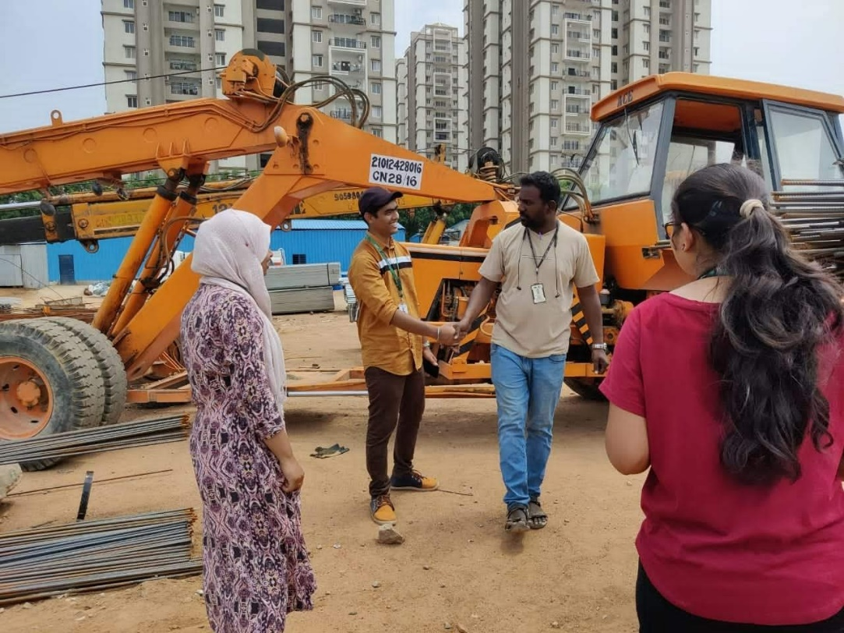



IMG4: Group discussion about the solution

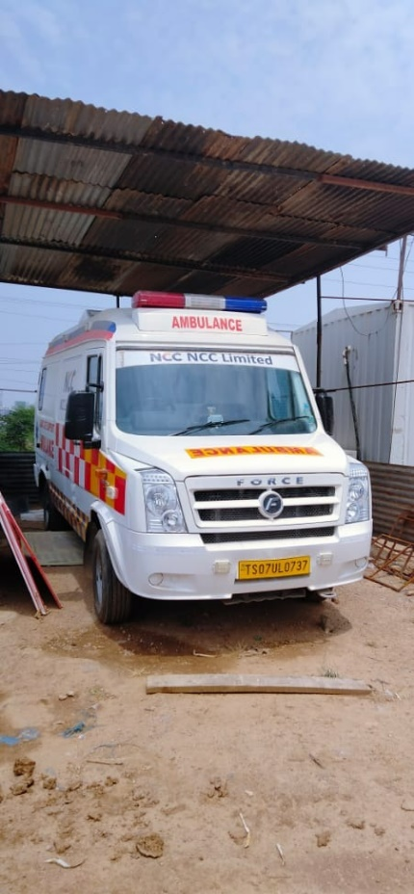­­­­­­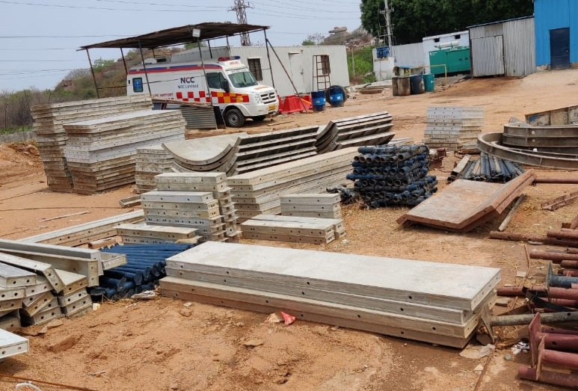

IMG5: Ambulance for injured people. IMG6: materials in the construction site.

 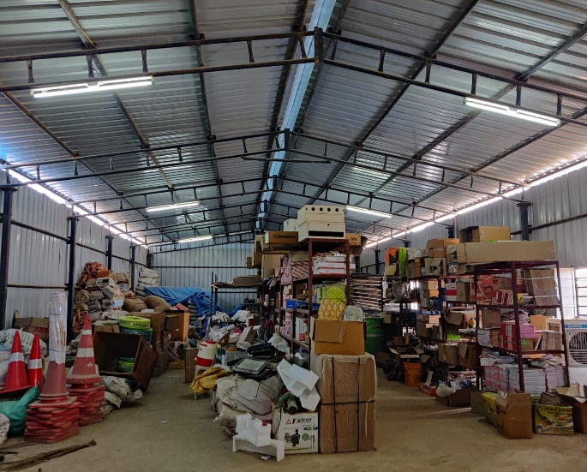 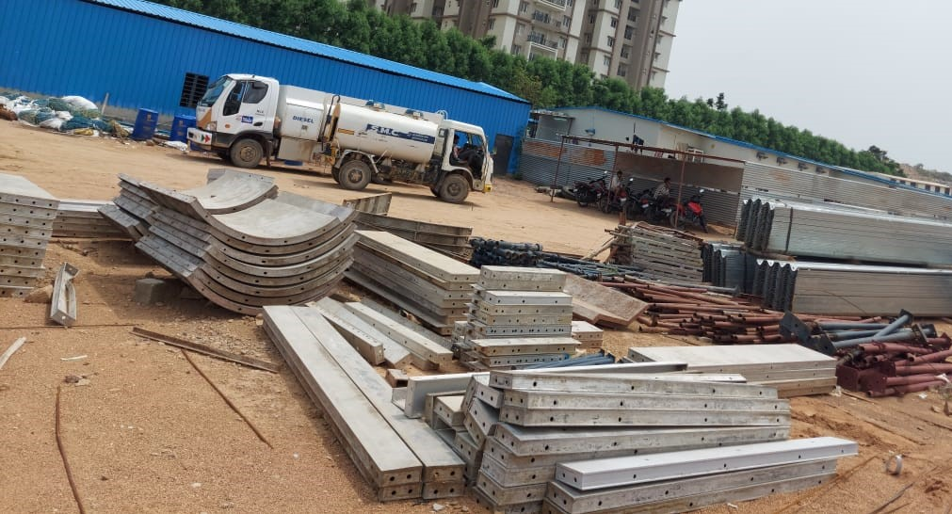

IMG7: Equipment on the construction site

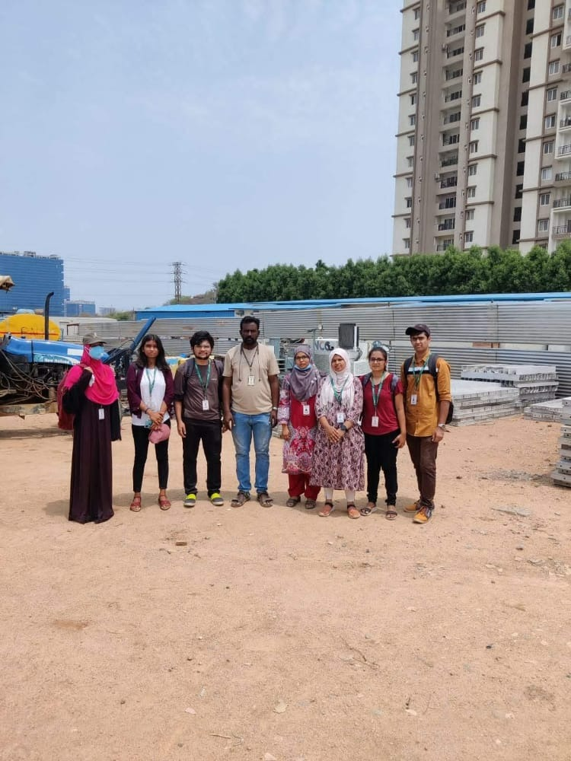



IMG8: A group image with our mentor

**8. Conclusions:**

In a span of 1 week, I was able to understand the problems and solutions made by the company for their betterment of the workers and also for the society by taking all necessary precautions for the reduction of pollution to an extent and also for the safety and security purpose of the people working in the company.

I also had a great experience by doing this project, I was happy by seeing the happy faces on people I interacted, and this project turned out to be one of the best experience in my life.



# ­­­­­

# Signature of the Student. Signature of the Mentor.

